

NAME: AJAY KUMAR REDDY
REG NO:192425274
COURSE CODE: MLA0214
COURSE NAME: FUNDAMENTAL OF MACHINE LEARNING
QUESTION: For a given set of training data examples stored in a .CSV file, implement and demonstrate the Candidate-Elimination algorithm in python to output a description of the set of all hypotheses
consistent with the training examplesAIM: To implement the Candidate Elimination algorithm to find the set of all hypotheses consistent with the training data.
ALGORITHM:
- Start the program.
- Initialize Specific boundary S and General boundary G.
- Read the training examples.
- If the example is positive, generalize S minimally.
- If the example is negative, specialize G minimally.
- Repeat until all examples are processed.
- Display the final S and G boundaries.

CODE:
import numpy as np
import pandas as pd
data = pd.DataFrame([
['Sunny','Warm','Normal','Strong','Warm','Same','Yes'],
['Sunny','Warm','High','Strong','Warm','Same','Yes'],
['Rainy','Cold','High','Strong','Warm','Change','No'],
['Sunny','Warm','High','Strong','Cool','Change','Yes']
])
concepts = np.array(data.iloc[:,:-1])
target = np.array(data.iloc[:,-1])
S = ['0'] * len(concepts[0])
G = [['?'] * len(concepts[0])]
for i,h in enumerate(concepts):
if target[i] == "Yes":
for x in range(len(S)):
if S[x] == '0':
S[x] = h[x]
elif S[x] != h[x]:
S[x] = '?'
else:
for x in range(len(S)):
if S[x] != h[x]:
G.append(S.copy())
print("Specific hypothesis:", S)
print("General hypothesis:", G)
OUTPUT:
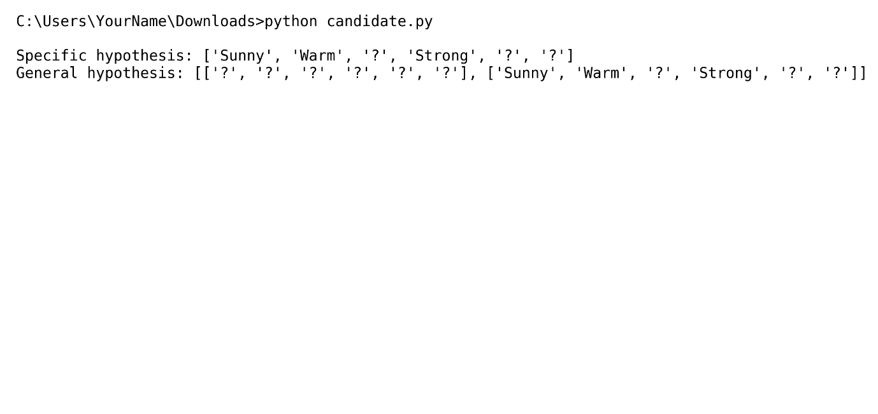
RESULT: The program successfully identifies the specific and general hypothesis boundaries.

